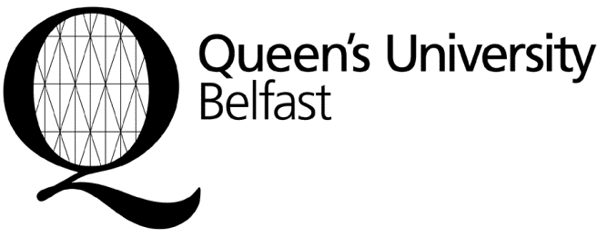
Income and Student Finance

Student Guidance Centre
Queen’s University Belfast
Belfast
BT7 1NN
Northern Ireland
United Kingdom
Tel: +44 (0)28 9097 2767
Fax: +44 (0)28 9097 2856
www.qub.ac.uk
incomeoffice@qub.ac.uk

Tuition Fee Payment Methods
Applicants holding unconditional offers can make a Deposit Payment or Early Bird Reward Payment by one of the three following methods.
1) Bank Transfer (TT)
Please ensure when making payment by bank transfer that:
- Your Bank quotes your full name and application number, and
- You complete and sign either the Deposit Payment Form (Appendix 1) or the Early Bird Reward Payment Form (Appendix 2) and return it to incomeoffice@qub.ac.uk
Bank Address: Ulster Bank Limited
91/93 University Road
Belfast
BT7 1NG
Northern Ireland
United Kingdom

Sort Code: 98-01-55

Account Number: 30090175

Account Name: The Queen’s University of Belfast - Tuition Fee Account.

Swift Code: ULSBGB2B

IBAN No: GB52 ULSB 9801 5530 0901 75

2) Bank Draft
Please ensure when making payment by bank draft that you send either the completed Deposit Payment Form (Appendix 1) or the Early Bird Reward Payment Form (Appendix 2) to the following address along with your bank draft and a copy of your offer letter.
Address: Income and Student Finance Office
Student Guidance Centre
Queen’s University Belfast
Belfast
BT7 1NN
Northern Ireland
United Kingdom

3) Credit Card
If you wish to make a payment by credit card, please call the Income and Student Finance Office: +44 (0)28 9097 2767. You will be required to quote your student application number (please see your offer letter). Please note we do not accept American Express or Laser Cards.

If paying by credit card please complete and sign either the completed Deposit Payment Form (Appendix 1) or the Early Bird Reward Payment Form (Appendix 2) and return it to incomeoffice@qub.ac.uk

